Below: Photo of community reps during jiv Below:The illegal bunkering point with 4’’ valve with nipple at 12o’clock position.
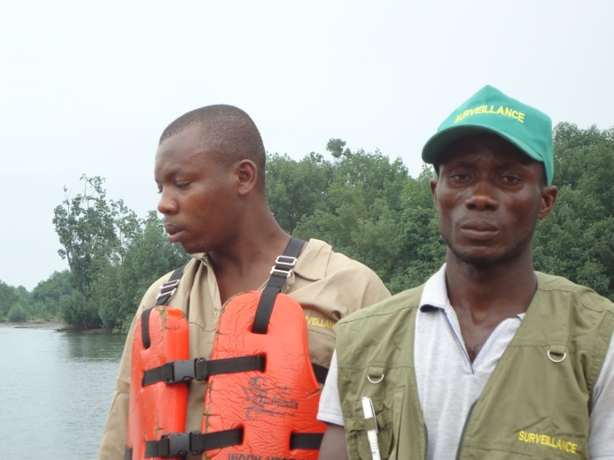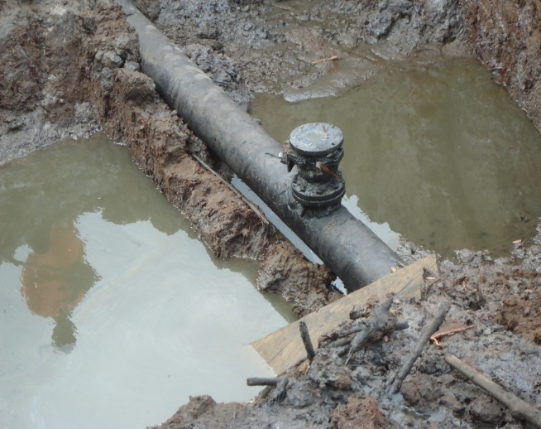
Photo showing pipe line with some of the planks photo showing the soil unimpacted during the
used by illegal bunkerers during their operations. time of this jiv. 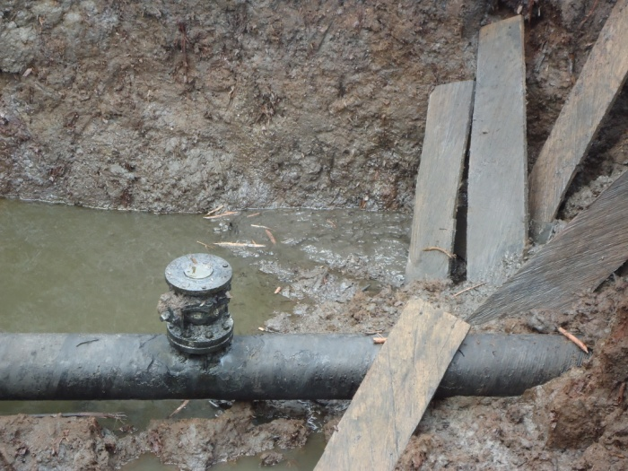 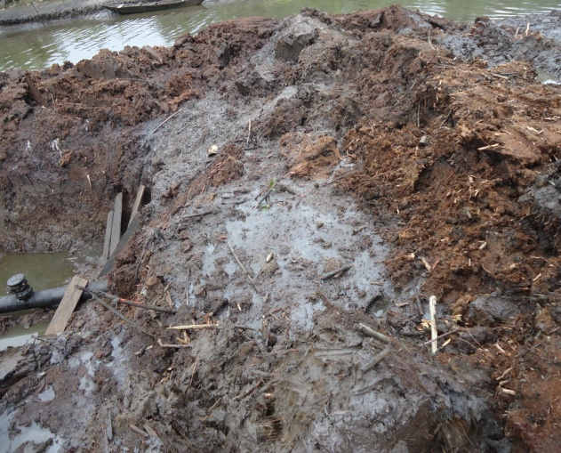
Below: Photo showing the pipe and hose used by the illegal bunkerers for their oil theft activities.

